Week3 Day1 Assignments:

*Home Assignments*
1) Use Bugmagnet extension for form filling

Fake Filler:
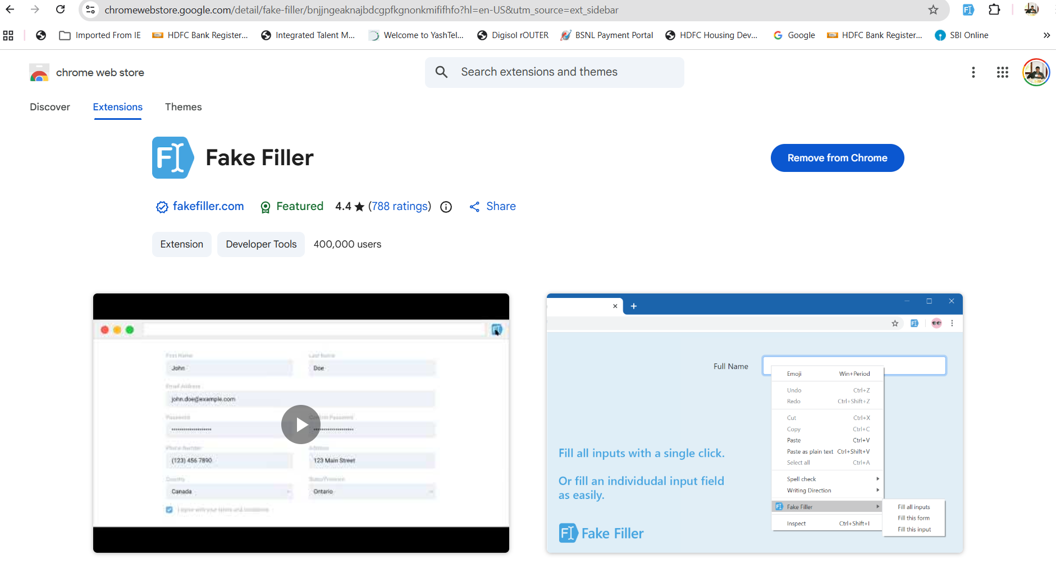

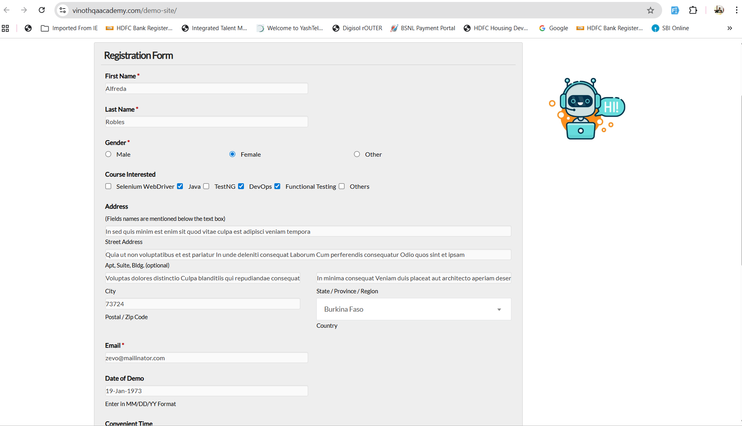

Bug Magnet:
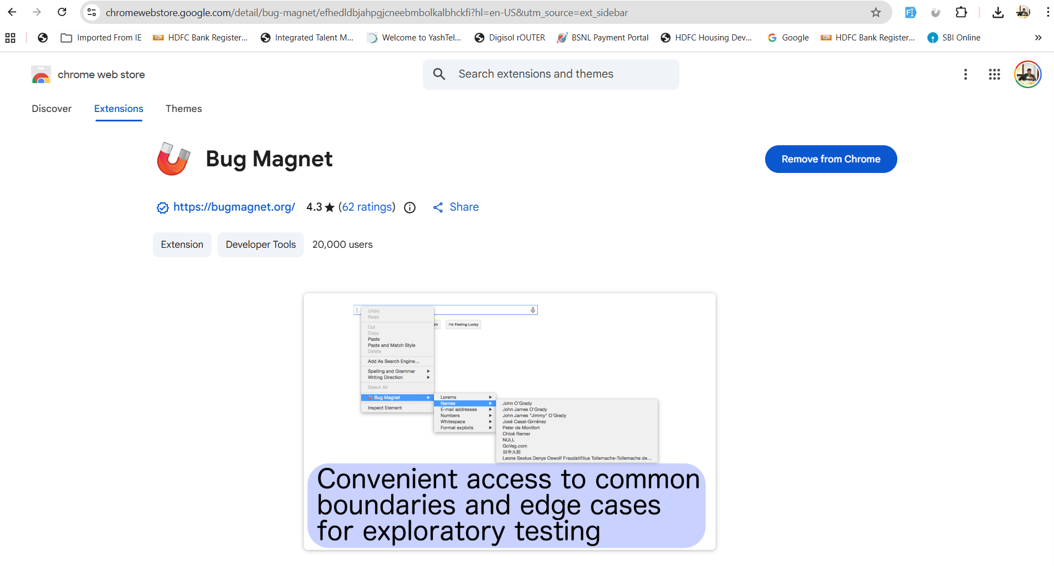

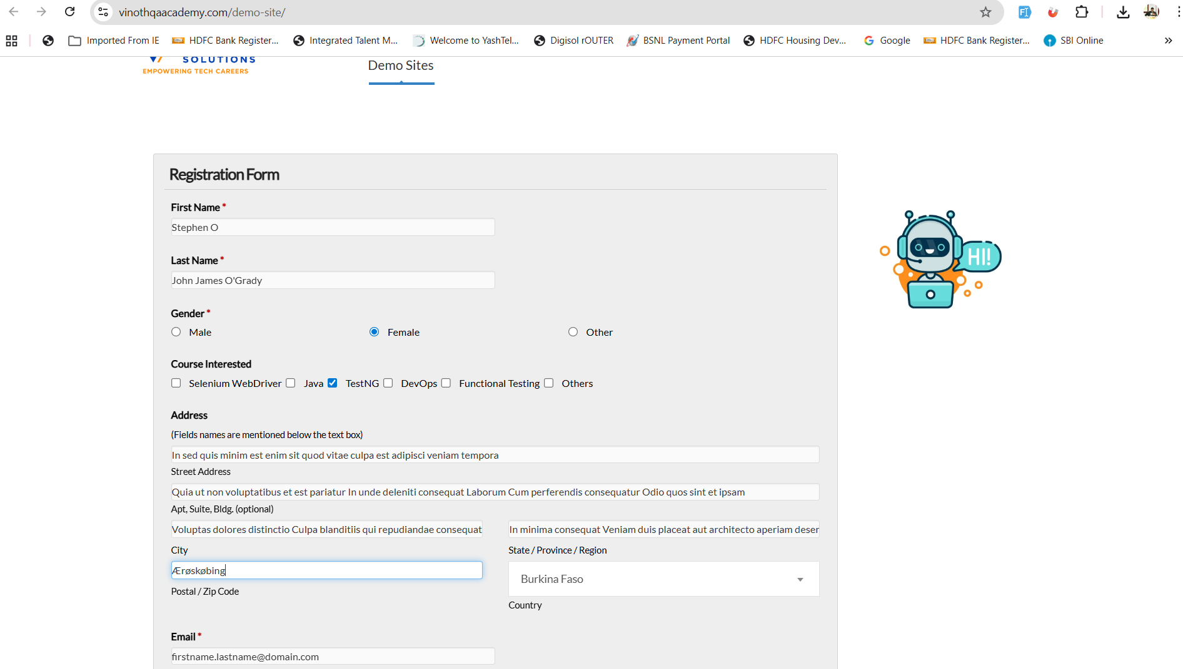

2) Use grammarly extension to correct the mistakes in your content

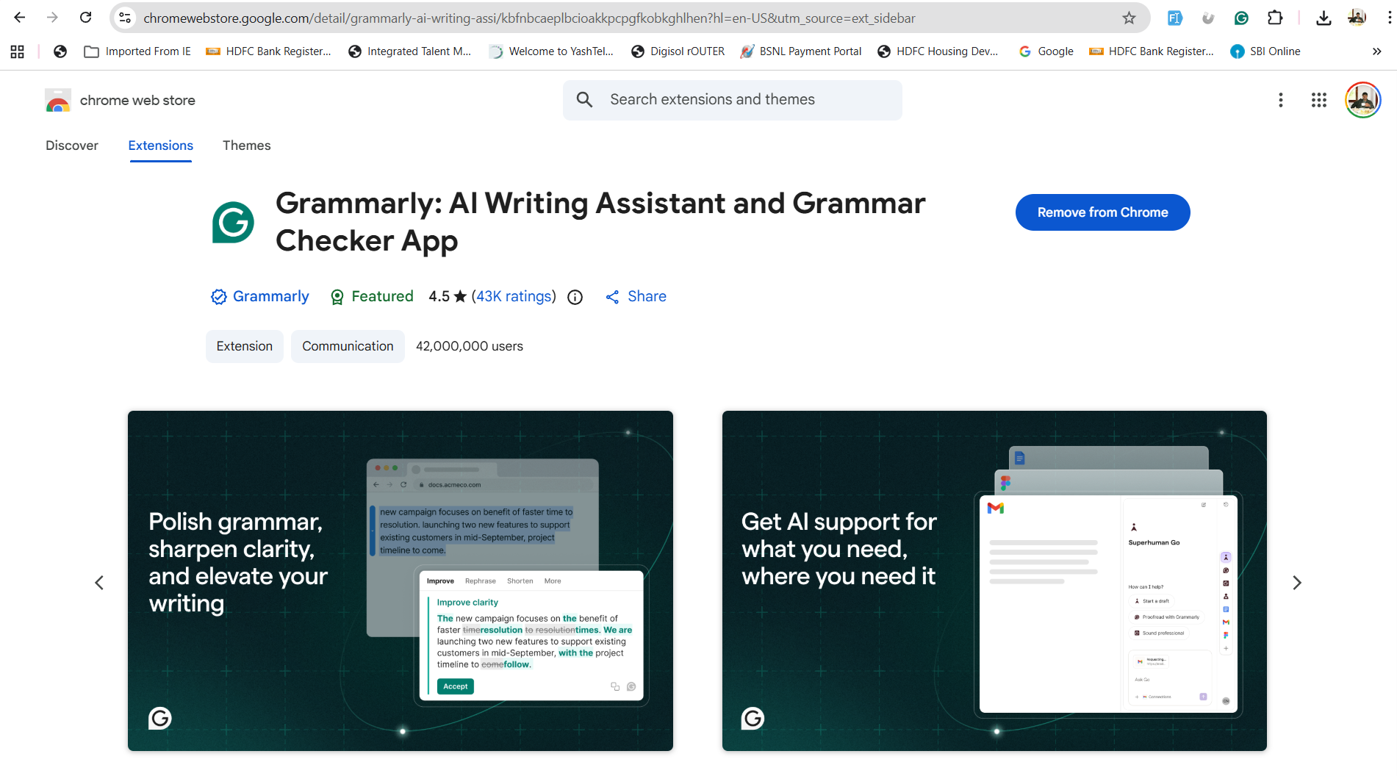

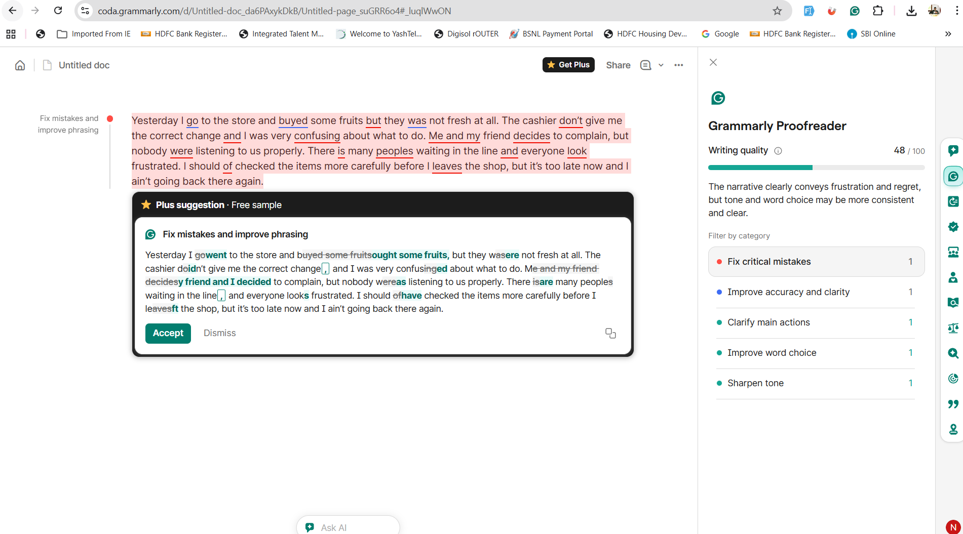

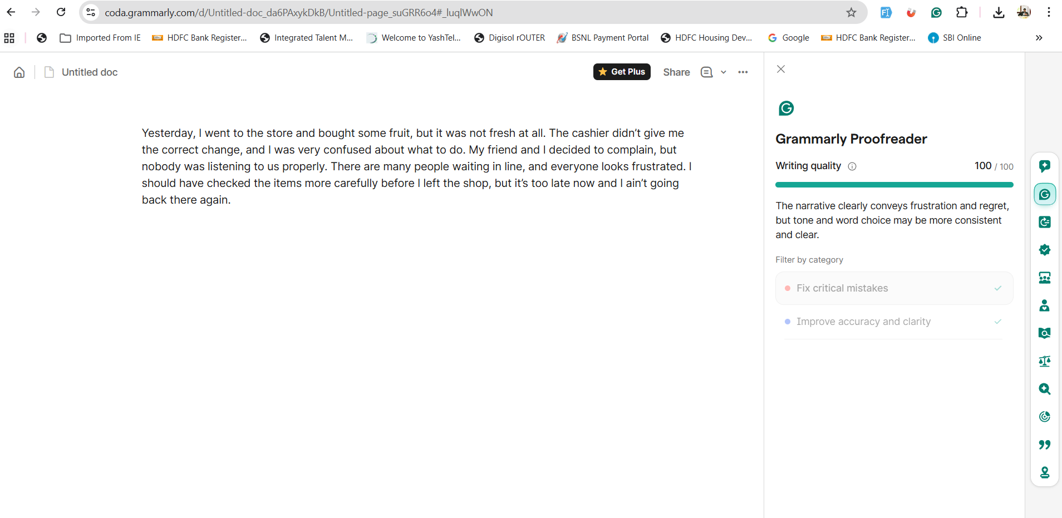

3) Vibe Coding Generate Playwright Typescript

<Pending>

